Workshop
3D Models Design as co-curricula workshop for GJU students
22nd of March 2017
GJU Vocational Training Center
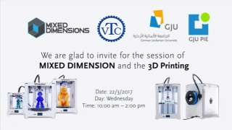

In the framework of continuous cooperation between the German Jordanian University and Mixed Dimensions Company, a workshop was organized on designing 3D models using sketchup software.
The workshop was organized on the 22nd of March 2017 by GJU Program Innovation & Entrepreneurship and hosted at the Vocational Training Center as a co-curricula activity for more than 15 engineering students. The session was delivered by Mr. Faisal AlNemri from Mixed Dimension’s Hackatari program which is a unique program as it offers several activities and skills development for university students to complement their academic learning that enable them to be ready for the market needs.
The students had to develop three models suitable for 3D printing utilizing the software tools techniques. As a prize to the participants, the best developed models will be printed in the GJU Innovation Lab which will be officially opened on the 12th of April along with the GJU Vocational Training Center.
For more information about 3Dprinting and the Program Innovation and Entrepreneurship (PIE) please contact: pie@gju.edu.jo
For more information about Vocational Training center at GJU please visit: gju.edu.jo/vtc

